31285 MOBILE APPLICATIONS DEVELOPMENT

Alexander Smith
11303563

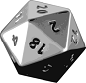

5th June 2012

Contents
1. Introduction 3
1.1 Purpose 3
1.2 Intended Audience and Reading Suggestions 3
1.3 Project Scope 3
1.4 Document Conventions 3
2. Functional Requirements 3
2.1 Application Functions 3
2.2 User characteristics 5
2.3 Operating Environment 5
2.4 Use Cases for Bluetooth Interaction 5
2.4.1 Connect to another device via Bluetooth 5
2.4.2 ‘Attack’ an opposing linked device’s character during a battle 5
2.4.3 ‘Heal’ a character while battling another linked device 6
2.4.4 Send user character data to another linked device 6
2.4.5 View all interactions with another linked device via a ‘battle log’ 7
3. Design 7
3.1 Package Structure 7
3.2 Application Interaction 8
3.3 Screen shots 8
4. System Testing 9
4.1 Testing Procedure 9
5. Conclusion 10

1. Introduction

1.1 Purpose
The purpose of this document is to provide information regarding the functionality, design and testing of the Battle Master (BM) application.

1.2 Intended Audience and Reading Suggestions
The intended audience of this document is aimed towards the tutors of the University of Technology, Sydney course Mobile Applications Development. However, those who wish to have a brief overview of the application itself are recommended to read the Functional Requirements section.

1.3 Project Scope
The BM application will act as an assistant in the interaction that occurs between those who play role-playing table-top (RPTB) games (i.e. Dungeons and Dragons). It will provide an interactive and fun means to accurately keep track of battles between two individuals. As RPTB games are traditionally played with pen on paper, they are unfortunately prone to miscalculations or cheating. Thus, the BM application shall eliminate these issues by keeping track of battle interaction.

Furthermore, the BM application will also provide a user with the tools to play RPTB games. As various sided dice are required to play these games, the application shall eliminate the need to purchase them. A user of the application shall have the ability to get randomised results of varying dice.

1.4 Document Conventions

Acronym | Term
BM | Battle Master
RPTB | Role-Playing Table-Top (Games)
DM | Dungeon Master
HP | Health Points
GP | Gold Pieces

2. Functional Requirements

2.1 Application Functions
The BM application shall possess the following functionality:

Name | Function | Priority (High, Medium, Low)
Create a character | The user shall have the ability to create and store a character with the following details: class name, character name, gender, level, health points (HP), description of character and the amount of gold pieces (GP) it has. | High
Create a minion | The user shall have the ability to create and store a Dungeon Master (DM) minion with the following details: name, race, level, HP and GP. | High
Connect to another device via Bluetooth | The user shall have the ability to connect to another device that is running the BM application. | High
Remove a character | The user shall have the ability to delete any store character. | High
Remove a minion | The user shall have the ability to delete any stored DM minion. | High
‘Attack’ an opposing linked device’s character during a battle | The user’s character shall be able to attack another linked device’s character | High
‘Heal’ a character while battling another linked device | The user’s character shall be able to heal itself and inform another linked device of its occurrence. | High
Send user character data to another linked device | The user shall be able to send their character data to another linked device prior to the start of the application’s battle simulation. | High
Roll Dice Simulation | The application shall provide the means for a user to get randomised results for 6 differently sided dice (4, 6, 8, 10, 12 and 20 sides). The results will be triggered by an accelerometer. | Medium
View all interactions with another linked device via a ‘battle log’ | The user shall have the ability to read all interactions between themselves and another linked device via a ‘battle log’ | Low
Ability to quickly randomise details when creating a minion | The user shall have the option of pressing several randomisation buttons that shall automatically implement the minion stats of names, levels, race, HP and GP | Low

2.2 User characteristics
The application will be designed for people who play and are familiar with RPTB games. A user of the application will only require a low understanding of technology as the user’s interaction will be basic (i.e. pressing buttons, reading instructions, etc.).

2.3 Operating Environment
The application shall be designed and tested on the Android platform version 2.3.3, which equates to API version 10. Thus, the platform and API version can be considered as the minimum requirements for a device. A device that does not meet these requirements may not have the ability to use a specific function of the application (i.e. Bluetooth services).

2.4 Use Cases for Bluetooth Interaction

2.4.1 Connect to another device via Bluetooth
ID | FR-01
Description | The user shall have the ability to connect to another device that is running the BM application.
Actors | - 2x Users
Pre-conditions | - Both users both have created a character and/or minion to use for the Bluetooth battle  - Both devices are capable of Bluetooth interaction
Events | - User selects either DM or Player mode  - User selects their previously created minion/character  - User allows the device to begin a Bluetooth connection when prompted  - User presses the menu button and selects to connect to a device  - User finds and selects a nearby device  - User connects to the device
Extensions | N/A
Post-conditions | - The user can now send their character data to the paired device
Priority | High

2.4.2 ‘Attack’ an opposing linked device’s character during a battle
ID | FR-02
Description | The user’s character shall be able to attack another linked device’s character
Actors | - 2x Users
Pre-conditions | - A Bluetooth battle is currently in session
Events | - User clicks the attack EditText and enters a numeric value  - User clicks the attack button to send the attack and a hitting sound is played  - Opposing connection receives the attack and a hurt sound is played
Extensions | N/A
Post-conditions | - Application updates the UI in regards to changes in character HP.
Priority | High

2.4.3 ‘Heal’ a character while battling another linked device
ID | FR-03
Description | The user’s character shall be able to heal itself and inform another linked device of its occurrence.
Actors | - 2x Users
Pre-conditions | - A Bluetooth battle is currently in session
Events | - User clicks the heal EditText and enters a numeric value  - User clicks the heal button to heal themselves and to inform the other device. A healing sound is played  - Opposing connection receives the heal information and a healing sound is played
Extensions | N/A
Post-conditions | - Application updates the UI in regards to changes in character HP.
Priority | High

2.4.4 Send user character data to another linked device
ID | FR-04
Description | The user shall be able to send their character data to another linked device prior to the start of the application’s battle simulation.
Actors | - 2x Users
Pre-conditions | - A Bluetooth battle is currently in session
Events | - Once the user has connected to another device via Bluetooth, the send character data button will be enabled  - The user clicks the button and the data is sent to the opposing device  - The send character data button disappears
Extensions | N/A
Post-conditions | - The UI shall be updated to display the opposing device’s character information
Priority | High

2.4.5 View all interactions with another linked device via a ‘battle log’
ID | FR-05
Description | The user shall have the ability to read all interactions between themselves and another linked device via a ‘battle log’
Actors | - 2x Users
Pre-conditions | - A Bluetooth battle is currently in session
Events | - A user presses any of the interactive Bluetooth buttons  - The results and/or details are recorded in a ListView at the bottom of the screen.
Extensions | 3a. User wins or loses a battle  - The ListView battle log shall inform a user on whether they lose or win a Bluetooth battle.
Post-conditions | N/A
Priority | Low

3. Design

3.1 Package Structure

The BM application has been structured within the following class packages:
- id11303563.asmith.dnd:
  - User interface and screen activities
  - Bluetooth services
- id11303563.asmith.dnd.adapters:
  - Minion and character item adapters
- id11303563.asmith.dnd.characters:
  - Minion and character SQLiteHelpers
  - Minion and character objects
- id11303563.asmith.dnd.views:
  - Minion and character item ListView interfaces

3.2 Application Interaction

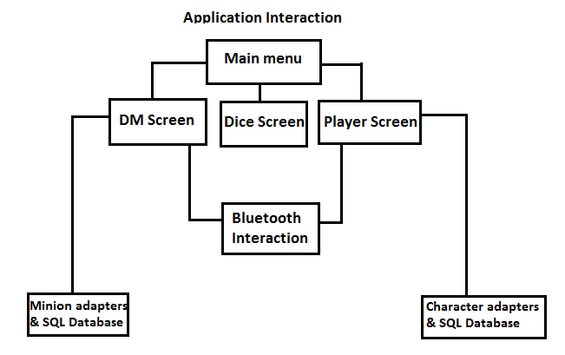
Figure 1
As shown from the diagram above (Figure 1), both the player and DM users have their own SQL databases and adapters. Both sides of the application are brought together through the use of Bluetooth services. Also, the interactive dice function can only be accessed from the first main menu.

3.3 Screen shots
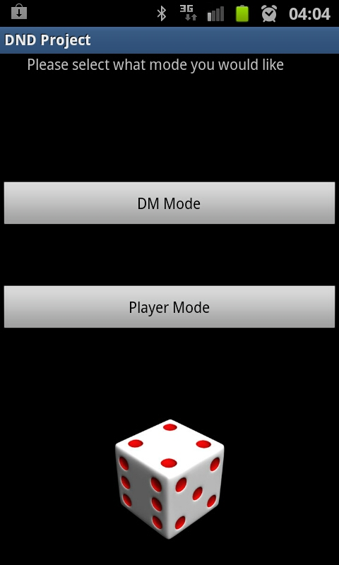  Main Screen 1 | 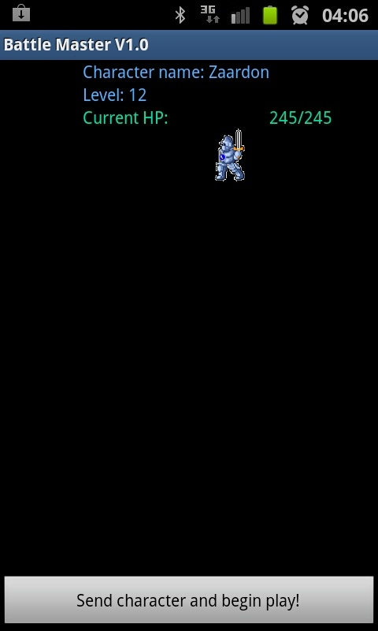  Bluetooth Screen 1 | 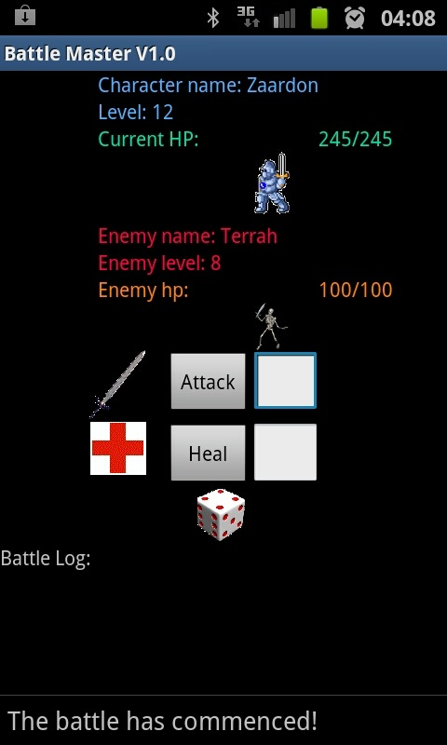  Bluetooth Screen 2
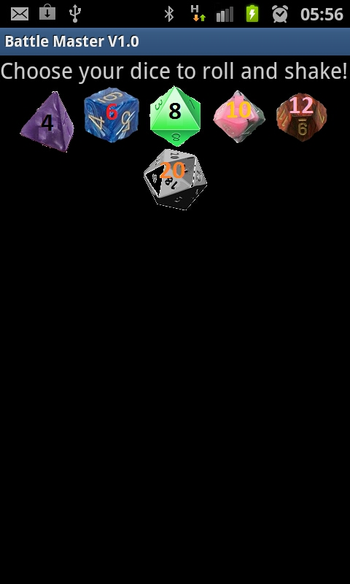  Dice Screen 1 | 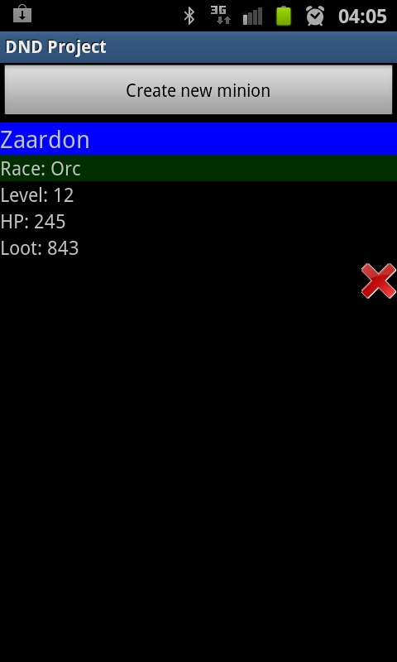  DM Screen 1 | 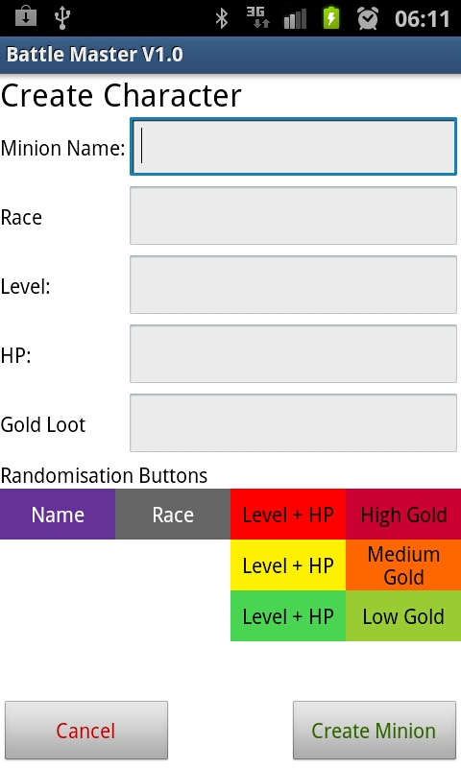  DM Screen 2
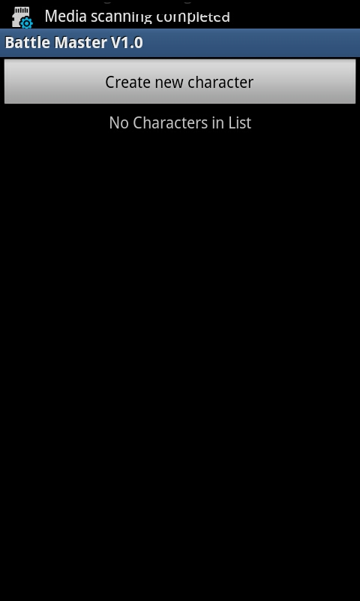  Player Screen 1 | 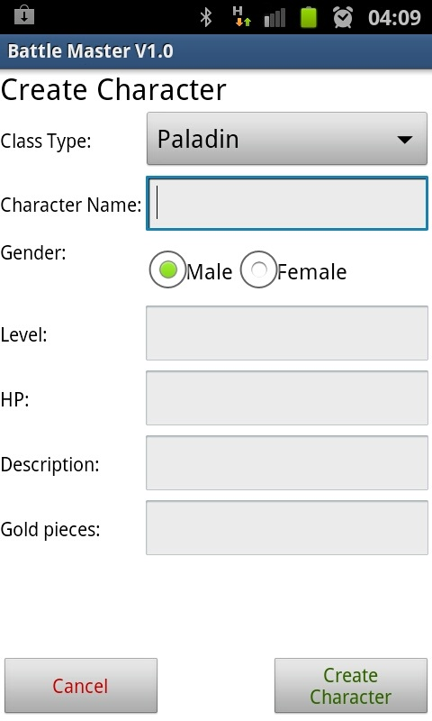  Player Screen 2

4. System Testing

4.1 Testing Procedure

Upon each session of programming, a back-up will be made of the application with the date attached. This is to ensure that:
- Back-ups exist for each implementation
- Roll-backs can occur in the event that newly implemented code breaks the system

The application will be then be run on the Eclipse emulation software and any new implementations will be tested. In the event that something should break, it will be possible to debug the error via Eclipse’s debugger and LogCat functionality.

In the event of testing Bluetooth functionality, two android devices with an API of 10 or higher will be required. This is due to the emulation software being incapable of simulating a Bluetooth environment.

5. Conclusion

The Battle Master application has provided the means to display and create the following android functionalities:
- Bluetooth interaction and functionality
- Various types of animations
- Accelerometer interaction
- Playing sounds
- Data storage and retrieval
- Effective use of encoding/decoding messages to transfer data across a Bluetooth connection

In summary, the Battle Master application shall provide an easy means to keep track of on-going battles that occur within a RPTB game. It shall also eliminate the need for a player to own physical game dice.

